EXPT NO:8 | FORECASTING AND PREDICTIVE ANALYTICS USING TABLEAU  AND POWER BI
DATE: 14.08.2026

PRE-LAB QUESTIONS (PROVIDE BRIEF ANSWERS TO THE FOLLOWING QUESTIONS) :

- What is forecasting in the context of Business Intelligence (BI)?
Forecasting in BI is the process of predicting future outcomes using historical data.
It helps businesses identify future trends and patterns.
Forecasting can be used for sales, demand, revenue, and other business activities.
It supports better planning and decision-making.

- Explain the difference between predictive analytics and descriptive analytics.
Descriptive analytics explains what happened in the past using historical data.Predictive analytics uses historical data to predict what may happen in the future.Descriptive analytics focuses on past performance and trends.Predictive analytics helps organizations prepare for possible future outcomes.

- Name two common forecasting methods used in Tableau and Power BI.
Two common forecasting methods are time-series forecasting and moving averages.Time-series forecasting uses historical data over time to predict future values.Moving averages smooth data to identify trends and reduce short-term fluctuations.Both methods can help businesses understand future patterns and make informed decisions.

- Why is data granularity important for accurate forecasting?
Data granularity refers to the level of detail available in a dataset.The right level of granularity helps identify accurate trends and patterns.Too much detail can make the analysis complex, while too little detail may hide important patterns.Therefore, appropriate data granularity improves the reliability of forecasts.

- Name two challenges in forecasting using multiple data sources.
One challenge is that different data sources may have inconsistent formats.Another challenge is mismatched or missing values between datasets.These issues can affect the accuracy and reliability of the forecast.Proper data cleaning and integration are needed before performing forecasting.

IN-LAB EXERCISE:
OBJECTIVE:
To perform time series forecasting and predictive analytics on historical sales data using Tableau and Power BI, and visualize future trends for informed decision-making. PROCEDURE:
- Data Collection:
  - Import historical sales data from multiple sources:
    - Dataset 1: Sales Data (CSV) → Order ID, Order Date, Region, Sales Amount
    - Dataset 2: Promotions Data (Excel) → Promotion ID, Region, Promotion Start Date, Promotion End Date, Discount
- Data Preparation and Transformation:
  - Clean data: standardize date formats, remove duplicates, handle missing values.
  - Aggregate sales data at the required granularity (daily, weekly, or monthly).
  - Ensure numeric fields (Sales, Discount) are correct.
- Data Integration and Modeling:
  - Tableau: Connect datasets and relate them using the Region field.
  - Power BI: Create relationships in the Model view; define cardinality where necessary.
- Forecasting and Predictive Analytics:
  - Tableau:
    - Use the Forecast feature on Sales over time. o Apply trend models like Exponential Smoothing and visualize prediction intervals.
  - Power BI:
    - Use built-in forecasting in line charts. o Optionally, create a DAX measure for predicted sales using moving averages or linear regression.
- Create Calculated Fields:
  - Forecasted Sales = Predicted value from the model
  - Sales Growth % = ((Forecasted Sales – Actual Sales) / Actual Sales) * 100
- Design a Comprehensive Dashboard:
  - Line chart showing actual vs. forecasted sales over time.
  - KPI cards: Total Forecasted Sales, Expected Growth %.
  - Use combo charts to show sales trends along with promotion periods.
  - Highlight regions with expected growth above or below target thresholds.
- Validate Forecast Accuracy:
  - Compare forecasts against actual historical sales (back-testing).
  - Adjust forecasting parameters if necessary (e.g., seasonality length, smoothing factor).
- Publishing and Sharing:
  - Tableau: Publish workbook to Tableau Public or Tableau Server.
  - Power BI: Publish report to Power BI Service and share with stakeholders.
Experiment Datasets:
  - Dataset 1: Historical Sales Data (CSV) → Order ID, Order Date, Region, Sales
  - Dataset 2: Promotions Data (Excel) → Promotion ID, Region, Promotion Start/End Date, Discount

Tableau dashboard:
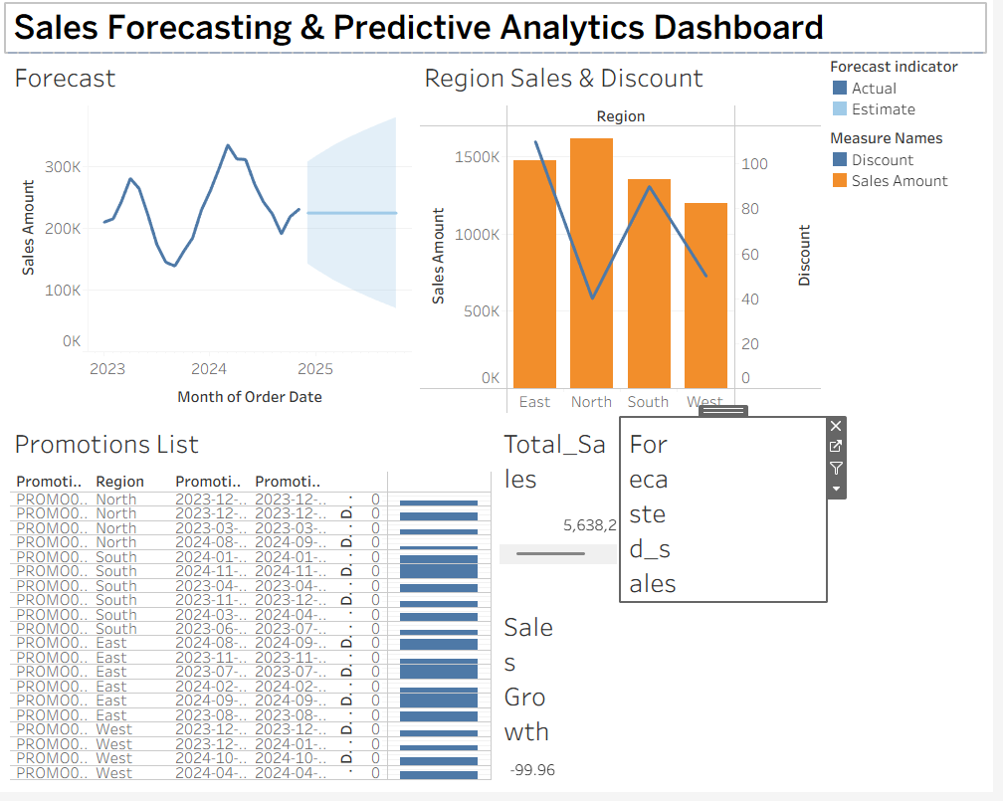
Power BI Dashboard:
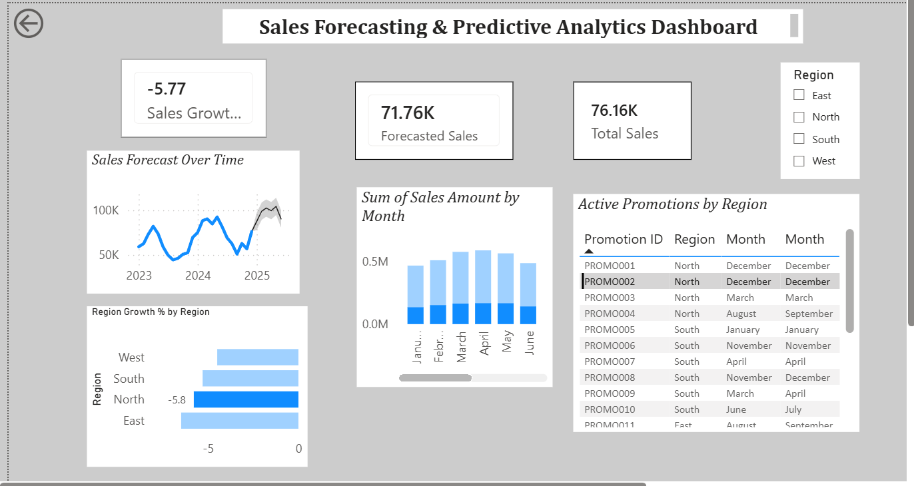

POST-LAB QUESTIONS (PROVIDE BRIEF ANSWERS TO THE FOLLOWING QUESTIONS) :
- How did forecasting help in predicting future sales trends for business planning?

Future sales trends were predicted using historical sales data.Possible increases or decreases in sales were identified through forecasting.Better inventory and resource planning were supported by the predicted trends.More informed business decisions were therefore made.

- What forecasting method did you use, and why was it suitable for the dataset?

Time-series forecasting was used for predicting future sales values.It was considered suitable because sales data was recorded over different dates.Trends and patterns in sales over time were identified using this method.Therefore, future sales performance could be estimated more effectively.

- What challenges, if any, did you face regarding missing data or irregular time intervals?

Some missing or incomplete values were found in the dataset.
Irregular time intervals were also observed in some records.
The data was cleaned and the date values were checked before forecasting.
The reliability of the forecast was improved through proper data preparation.

- How can predictive analytics influence decision-making in a retail environment?

Future sales and customer demand can be estimated using predictive analytics.Inventory levels can be planned based on the predicted demand.Pricing, promotions, and product decisions can also be improved.More data-driven decisions can therefore be made in a retail environment.

- What additional data (e.g., competitor pricing, economic indicators) could be integrated to improve forecast accuracy?
Competitor pricing data could be integrated to identify market changes.Economic indicators such as inflation and consumer spending could also be included.Customer behavior, promotional activities, and seasonal trends could be considered as well.Higher forecast accuracy could be achieved by combining these additional data sources.

RESULT:
The historical sales and promotions datasets were successfully cleaned, integrated, and modeled in Tableau and Power BI. Forecasting techniques provided predicted sales trends, growth percentages, and region-wise performance expectations. The resulting dashboards allowed managers to visualize actual vs. forecasted sales, enabling better planning and datadriven decision-making.

ASSESSMENT

Description |  | Max Marks | Marks Awarded
Pre Lab Exercise |  | 5
In Lab Exercise |  | 10
Post Lab Exercise |  | 5
Viva |  | 10
 | Total | 30
 | Faculty Signature

